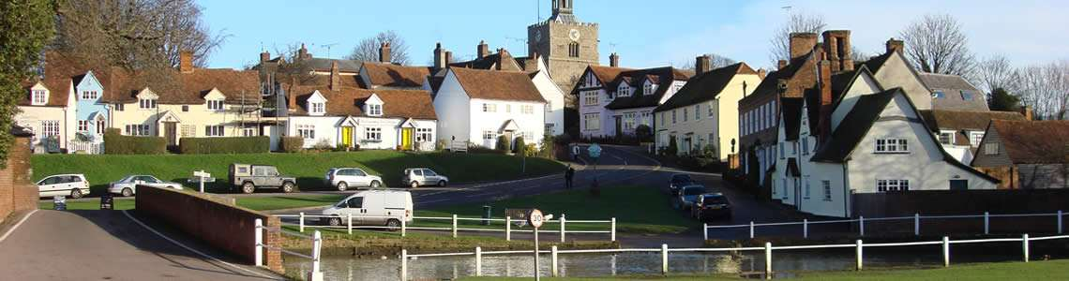
FINCHINGFIELD PARISH COUNCIL

REPRESENTING FINCHINGFIELD AND CORNISH HALL END.
Members of the Parish Council are hereby summoned to attend the Parish Council Meeting to be held at Cornish Hall End Village Hall, on Tuesday 25 October 2022 commencing at 7:30pm, for the purpose of transacting the following business:
The meeting will be open to the public unless the Council directs otherwise.

AGENDA

- Apologies for absence.
- To receive member’s declarations of interest and dispensations in items on the
agenda. Dispensations should be requested from the Clerk up to the day before the meeting.

- Minutes: Acceptance of the minutes from the Finchingfield Parish Council Meeting held on 27 September 2022.

- Public participation session with respect to items on the agenda and other matters that are of mutual interest or local concern: A maximum of 15 minutes shall be allowed for public question time, and it is requested each member of the public speak for a maximum of 3 minutes.

- To receive a report from the District and/or County Councillors.
- Clerks Report: To receive a report from the Clerk.

- Co-option: To consider co-opting interested candidates onto the Parish Council to fill the vacancy in the Finchingfield ward.

- The Civility and Respect Pledge. To sign the Civility and Respect Pledge.

- Parking, Speeding and Vehicle Noise: To receive an update on the consultation process with Cornish Hall End residents regarding traffic calming.

- Cornish Hall End Village Hall Car Park and Playing Field, To review quotes, agree a contractor and funding for the disabled access.

- Cornish Hall End Pavilion. To consider Pavilion renovation and Play Equipment re-siting, repair and maintenance, including PC funding and other fund raising.

- Patricia Grange Sign. To agree acceptance of the installation quotation.

- Community Energy Generation Project. To receive an update and agree to a viability study.

- Jubilee Tree Planting. To receive an update and agree a location for planting.

- Sluice Gate Repairs and Faulty Winding Gear. To receive an update and agree payment.

- Highways and Public Rights of Way.
- To ratify PC approval of two remaining LHP scheme applications:
  - Finchingfield Green disabled parking bays.
  - The removal of the yellow lines outside the Granary
- To receive an update on Footpath 31 hedges and trees needing to be cut.
- To receive an update on Footpath 2 diversion.
- To consider an application to Essex Highways to reduce the speed limit between Finchingfield to Gt Bardfield to 40mph.
- To consider 20’s Plenty for Finchingfield’s village speed limit.
- To consider writing to all PC’s in Essex regarding speeding and vehicle/motorbike noise to identify if this is a problem in their Parish and if they would like to be part of a pan Essex group to try and make changes to this issue.
- Footpath repairs.

- Stephen Marshall Avenue Play Area.
- To agree actions needed on damage to the boundary fence.
- To agree actions needed from the inspection report.
- To agree removal of the hedge at the playing field around the pavilion.

- Finchingfield Christmas Events.
  - To receive an update on the arrangements for the tree.
  - To agree a letter to Claire Collins regarding the location of the Christmas tree lights.
  - To consider other planning needed for Christmas.

- Warm Spaces. To consider opening warm spaces in the Parish this Winter

- Parish Council Storage. To agree storage for both Village Hall and Parish Council documents.

- Planning Committee: To agree to appoint a Committee.

- Winter Salt. To receive an update.

- Finchingfield Village Sign. To agree to repainting the village sign.

- Children’s Play Area Bench. To receive an update.

- Finchingfield Playing Field. To agree for works to be carried out at a cost of £1000.00.

- Finance.
- To receive an update and approve payments.
- To review the current method for raising and paying invoices.
- To identify earmarked reserves in lines with the Reserves Policy for review and adoption before the January 2023 meeting
- To agree to appoint a Finance Committee.

- Planning: To agree a response to the following applications:
22/02682/HH
Proposal: Single storey extension to existing detached garage.
Location: Gatwards Cottage , Vicarage Road, Finchingfield

22/02676/COUPA
Prior approval for the change of use of agricultural building to a dwelling house (class C3) and for associated operational development – change of use to 1no. residential dwelling.
Locksmiths Farm, Robinhood End, Finchingfield

Reference: 22/02701/FUL
Proposal: Re-cladding and change of use of existing barn to TV/film studio, plus ancillary works.
Location: Spains Hall, Spains Hall Road, Finchingfield

- Items for the next agenda.

- Next Meeting: Tuesday 29 November 2022.

D. Roder

Donna Roder
Clerk and RFO
Finchingfield Parish Council
19 October 2022

